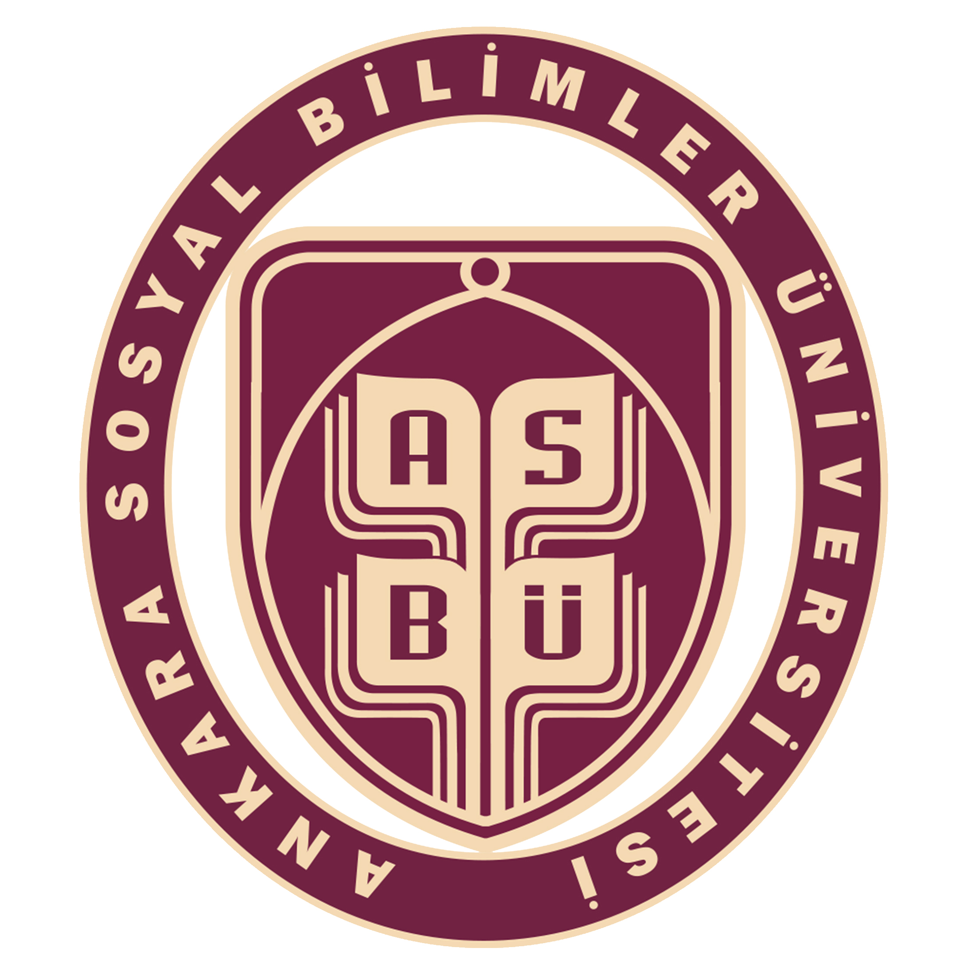LETTER OF INTENT
YOUR NAME AND SURNAME
ANKARA SOSYAL BILIMLER UNIVERSITESI,
Faculty of Art and Science
Bachelor’s Degree, Sociology
(4 years+1 years English Preparation Programme)
To whom it may concern,
This is to confirm that we accept the student named above for the internship under the Erasmus+ Programme for 3 months, from 1/12/2017 to 3/12/2017.
If you need further information, please do not hesitate to contact us.
Company Name: | ***
Company Address: | ***
Company Website: | ***
Company Telephone Number: | ***
Company Email: | ***
Type of Organisation: | ***

As the manager ………… (name of the company) hereby I certify
- To organize the accommodation, the local transports and reception of candidates.
- To provide work and placements;
- To implement the follow-up procedures: monitoring will be on a regular basis, guidance and support will be available always to the participant;
- To organize a socio-cultural program and organize evaluation meetings;
- To Co-operate at all times with the sending organization and partner;
- To set-up structured information follow,
- To improve the common means for skill analysis and the qualified work labour,
- To Erasmus training program and certification.
I am looking forward to receiving you and your colleagues at our company, in our city.
City, 18th March 2017
!!! PLEASE DELETE THIS MESSAGE BEFORE PRINTING !!!
ALL THE HIGHLIGHED PARTS ARE REQUIRED.
PLEASE REMOVE ALL THE HIGHLIGHTS BEFORE PRINTING.

Manager
(Direct Manager)

