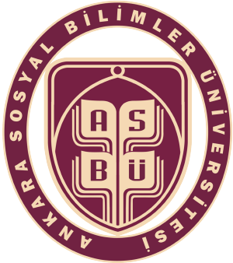

CERTIFICATE OF ATTENDANCE
FOR ERASMUS+ STAFF MOBILITY FOR TEACHING
It is hereby certified that
Full Name
a member of academic staff at the
Social Sciences University of Ankara (TR ANKARA23) in Türkiye
visited and carried out teaching activities at
Name of the University (Erasmus+ Code) in Name of the Country
between
…/…/20… and …/…/20…
within the framework of Erasmus+ Staff Mobility for Teaching in accordance with the Mobility Agreement for Staff Mobility for Teaching signed bilaterally prior to the mobility period within the frame of the Erasmus+ programme.
During the mobility period, the participant has fulfilled Number* hours of teaching activities as required by the Erasmus+ Programme in the following topics: Names/Topics of the Lectures.

Date: Signature & Stamp:

Name of the signatory:
Position:

*A minimum of 8 hours of teaching is required.

